4-H Online Junior Fair Family Entry
Important Notes
- The Shawano County Junior Fair Entries are due August 1. Be sure to complete your entry (including the final “Submit” step) prior to the cut-off date.
- Recommended browsers: Google Chrome or Mozilla Firefox. Older versions of Internet Explorer may cause unexpected results.
- Register all entries for each exhibitor in the family before proceeding to the Payment section. The processing fee will be paid by your club or chapter so do not worry about payment within this system.
- Be sure to click the “Submit” button when you have completed all family member entries. Entries are not final until they have been submitted.
- Check your email inbox for a confirmation email with a list of your entries and any related fees.
- You will receive a second email when your entries have been approved by your fair.

Steps  - Go to http://www.fairentry.com and click “Find Your Fair”. | 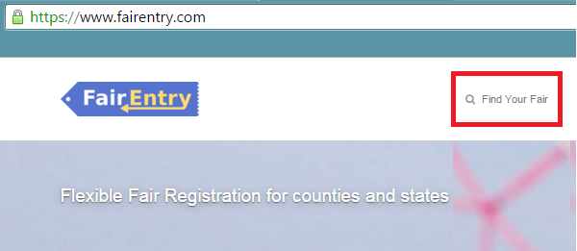
- Filter by your state, click Search, and then click on the correct fair.  (If you type in Shawano in WI our fair will be the only one to come up.) | 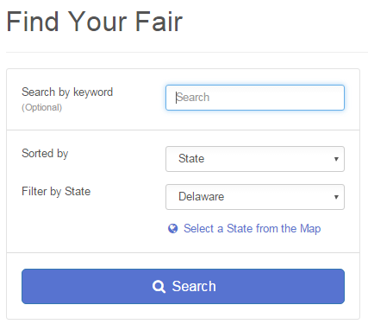
- Click on the green “Sign in with 4hOnline” button. This will pull up the sign in window for 4hOnline. Using your 4hOnline e-mail and password log in as a family.
- IMPORTANT: If you don’t have a valid e-mail for a reply e-mail, send Charlotte an e-mail so she can confirm your entries have been entered. (charlotte.schwartz@co.shawano.wi.us)
- Click “Begin Registration” | 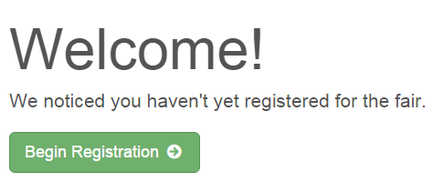
Exhibitor Information  Click on the “Individual” button. | 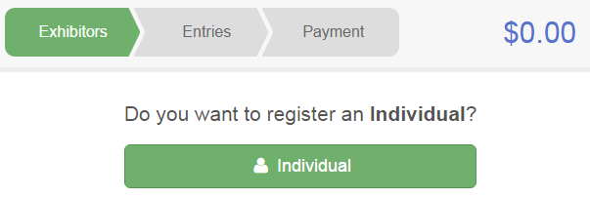
- Select a family member that is ready to begin entering. Click Continue when all information is entered.

- Click the button that correctly answers the question. Hit Continue.

- Review your exhibitor information. If any information is incorrectly, click the green Edit button in the appropriate group to change it. When all information is correct, click Continue to Entries. | 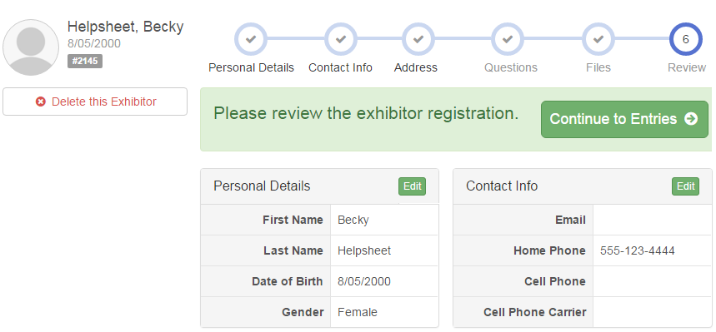

Creating Entries

Each exhibitor can have multiple entries. One entry must be made for each item, animal, class, etc. If an exhibitor is showing one horse in 3 events, three class entries must be created. Once all entries have been created for the first exhibitor, you have the choice of creating another exhibitor in this family (and entries) or proceeding to check-out (submitting the entries, whether or not fees are charged).

- Click Add an Entry beside the correct exhibitor (if more than one has been created). | 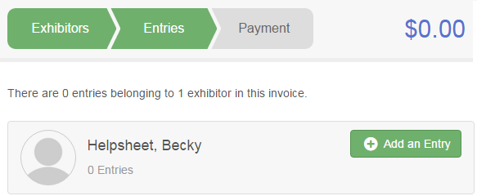
- Click Select beside the first department you wish to enter. BE SURE TO SELECT PROJECTS IN THE 100 SERIES OF NUMBER AS THESE ARE JUNIOR FAIR. Any departments that are not available for entry will be noted as “Not Available” with a short explanation AFTER you try to select them.  - After you select a department, you will see a list of divisions to select from, and then a list of available classes. Also notice that there are blue “Change” links. Once you have created an entry, you can simply “change” the department or division to go to your next entry.  - Make the appropriate selections on each screen and click green Continue button. IF you are in 4-H AND FFA, be sure to SELECT THE  - This program will not let you enter more in a department (project) than what is allowed in the fair book. | Entry limits:  117-Cloverbud = 3 entries  118 A-B- Visual Arts = 15 entries  120 – Photography = 15 entries
- If this is an animal class entry, you may be required to specify which animal will be exhibited in this class. If so you will see the option to “Add an animal”.  - Fill in all of the fields with information about the animal you intend to exhibit. Click Create and Add Animal when finished. (If livestock and you have multiple animals, enter ear tags with a dash (104-106). If planning on entering 2 animals, enter this two times. Can list the same ear tags numbers.  - If the animal information was entered incorrectly, you have the option to either “Remove From Entry” (creating a new animal) or Edit Animal Details. When it’s correct, click Continue. | 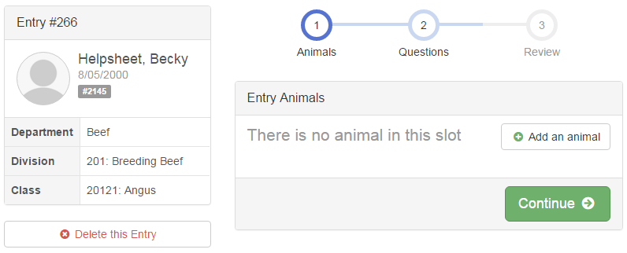

- Any questions or file uploads related to entry in this class will be next. Click Continue after answering those questions or uploading documents.  - The Review screen allows you to double check this entry for accuracy, and make any changes necessary. When the information is correct, click Continue (=SAVE) and that class entry is complete. | 9. None in 2018, but may be an option in the future.
- When each class entry is complete, you have 3 choices for what to do next:  - If all class entries have been completed for one exhibitor, you can Register another Exhibitor in this family.  - If this exhibitor has more class entries to make, you can Add another Entry for this Exhibitor.  - If all entries for all exhibitors in the family have been completed, Continue to Payment to finalize and submit your entries. | 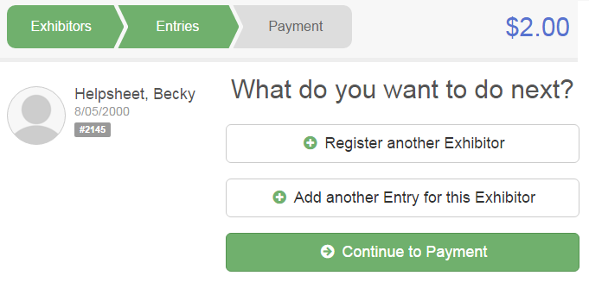
- Review your entries for completeness and accuracy. Notice the Summary and Detail buttons at the top of the list on the right. If there are errors, click on the green Entries section at the top of the page. Click Continue when all information is correct. | 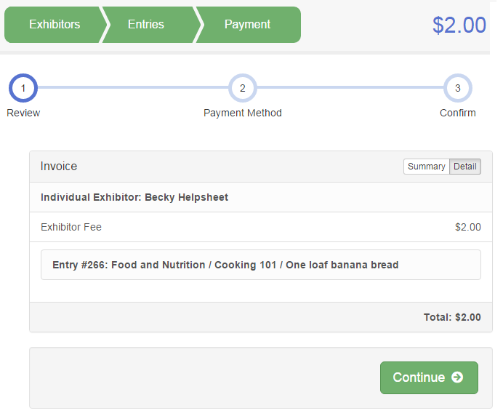

- Read the payment instructions and select your method of payment. Some fairs allow credit card payments, and others do not. NOTE: Even if you owe no money (no fees are charged) you must click Continue to the last “Confirm” step to submit your entries.

- Read the information in the “After you Submit” section. You may also have to check a box to “Agree to Terms”. Click Submit to finalize the entries for the exhibitors in this family. After you click Submit, no changes are possible to these entries.

**You can close the program and return at any time to review, change, correct your entries BEFORE you hit the submit button. Once that is hit, all Junior Fair changes need to called into or e-mailed to the:
UW-Extension Office
715-526-6136
charlotte.schwartz@co.shawano.wi.us

